EXPT NO:4 | TRANSFORM DATA TO SUIT BI REPORTING REQUIREMENTS AND  DESIGN A DASHBOARD WITH KEY PERFORMANCE INDICATORS (KPIs ) USING TABLEAU AND POWERBI
DATE: 24.07.2026

PRE-LAB QUESTIONS

1. What is the role of data transformation in BI reporting?
Data transformation converts raw, inconsistent data into a clean, structured format suitable for analysis. It involves cleaning, formatting, aggregating, and enriching data so that BI tools can generate accurate reports, visualizations, and KPIs.

2. What are the common data cleaning techniques in Tableau and Power BI?
Common techniques include removing duplicates, handling null/missing values, correcting data types (e.g., text to date), standardizing naming conventions, splitting/merging columns, and filtering out irrelevant data. Power BI uses Power Query Editor, while Tableau uses the Data Interpreter and Data Source pane.

3. How do Tableau and Power BI handle data aggregation?
Both tools allow aggregation using functions like SUM, AVERAGE, COUNT, MIN, and MAX. Tableau aggregates measures automatically based on the level of detail (dimensions) in a view, while Power BI uses DAX measures and the Group By feature to aggregate data at different levels.

4. What are KPIs, and why are they important in a dashboard?
KPIs (Key Performance Indicators) are measurable values that show how effectively an organization is achieving key objectives. They are important because they provide quick, high-level insights into performance, helping stakeholders make data-driven decisions at a glance.

5. What are the different types of charts available in Tableau and Power BI for visualization?
Common chart types include line charts, bar charts, pie charts, scatter plots, maps, heat maps, area charts, gauge charts, and KPI cards. Both tools also support tree maps, bullet charts, and combo charts for advanced visualization.

IN-LAB EXERCISE:
OBJECTIVE:
To transform COVID-19 data into a structured format suitable for Business Intelligence (BI) reporting and design interactive dashboards with Key Performance Indicators (KPIs) using Tableau and Power BI.
PROCEDURE:
- Data Collection:
  - Import the COVID-19 dataset from inbuilt sources like Our World in Data or CSV files containing country-level COVID statistics (e.g., new cases, deaths, vaccinations).
  - Datasets may include fields such as date, location, new_cases, total_cases, new_deaths, total_deaths, people_vaccinated, etc.
- Data Cleaning and Transformation:
  - Convert columns like date to proper date formats.
  - Handle missing or null values in new_cases, total_cases, etc.
  - Create calculated fields (e.g., daily case growth rate, case fatality rate, vaccination percentage).
- Data Aggregation:
  - Aggregate data by continent, country, or month.
  - Use measures like SUM(new_cases), AVG(positivity_rate), MAX(total_deaths).
- Designing KPIs:
  - Identify KPIs such as:
    - Total Confirmed Cases o Total Deaths o Case Fatality Rate o Vaccination Coverage (%)
    - Daily Case Growth Rate
  - Use DAX (Power BI) or Calculated Fields (Tableau) to compute and visualize these KPIs.
- Dashboard Development:
  - Build visualizations such as:
    - Line charts for daily new cases and deaths o Bar charts for country-wise vaccination progress o Maps to show regional case distribution
    - KPI cards for high-level insights
  - Use filters (e.g., by continent, country) and slicers (e.g., by date range) for interactivity.
- Publishing and Sharing:
  - Publish the dashboard using Tableau Public/Server or Power BI Service.
  - Share the dashboards with stakeholders through public or organizational portals.
Experiment Dataset: COVID-19 Global Dataset
Fields Used:
  - Date – Date of the report
  - Location – Country or region
  - New Cases – Daily reported cases
  - New Deaths – Daily reported deaths
  - People Vaccinated – Cumulative vaccinated count
  - Total Cases – Cumulative confirmed cases
  - Total Deaths – Cumulative deaths
  - Population – Total population of the country
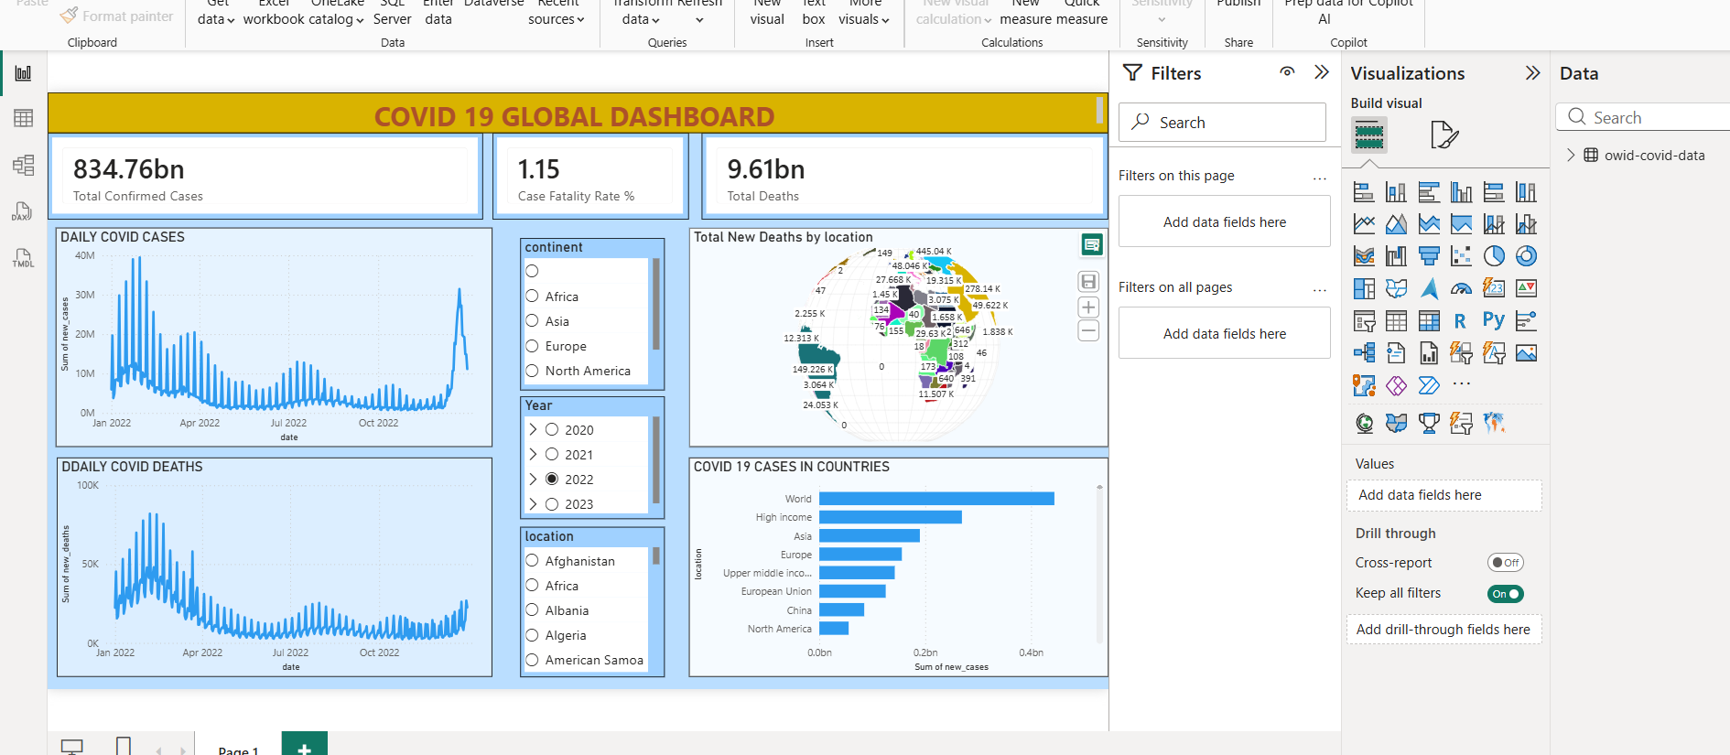
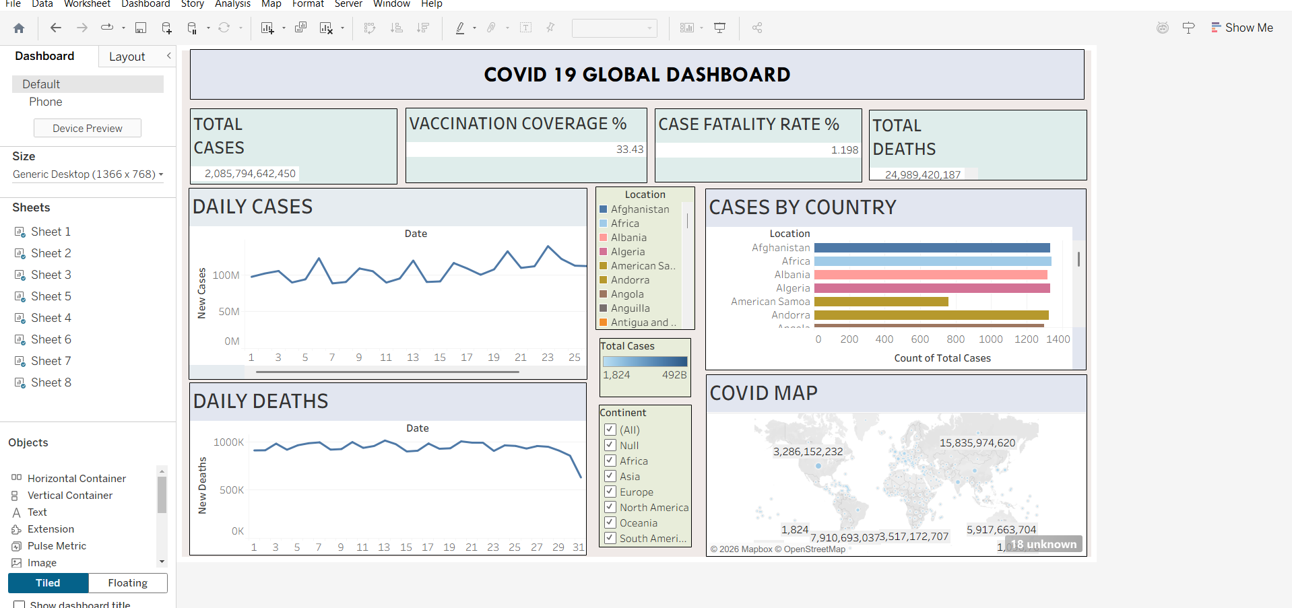

POST-LAB QUESTIONS
1. How did data transformation improve the quality of insights in your COVID-19 dashboard?
Data transformation removed inconsistencies and missing values, ensuring accurate case counts and death rates. This resulted in more reliable trend analysis and meaningful comparisons across countries and time periods.

2. What challenges did you encounter during the data cleaning process, and how did you resolve them?
Challenges included missing values in new_cases/new_deaths and inconsistent date formats. These were resolved by replacing nulls with zero or using interpolation, and converting date columns to a standard date format.

3. Which KPI provided the most valuable insight, and why?
The Case Fatality Rate provided the most valuable insight, as it showed the severity of the pandemic in different regions relative to the number of confirmed cases, helping identify high-risk areas.

4. How does interactivity in dashboards improve user experience?
Interactivity allows users to filter, drill down, and explore data based on their specific interests (e.g., by country or date), making the dashboard more engaging and enabling personalized, deeper analysis without needing multiple static reports.

5. What steps would you take to further enhance the dashboard's effectiveness?
Adding predictive analytics (forecasting future cases), more granular filters (age group, gender), mobile responsiveness, and real-time data refresh would further enhance the dashboard's effectiveness.

RESULT:

The COVID-19 dataset was successfully cleaned, aggregated, and transformed for visual analysis using Tableau and Power BI. Missing values, data type mismatches, and inconsistencies were addressed. KPIs such as vaccination rate and daily case growth offered valuable insights into the pandemic trends across countries and timeframes. The resulting interactive dashboards allowed for effective public health monitoring and communication.

ASSESSMENT

Description |  | Max Marks | Marks Awarded
Pre Lab Exercise |  | 5
In Lab Exercise |  | 10
Post Lab Exercise |  | 5
Viva |  | 10
 | Total | 30
 | Faculty Signature

